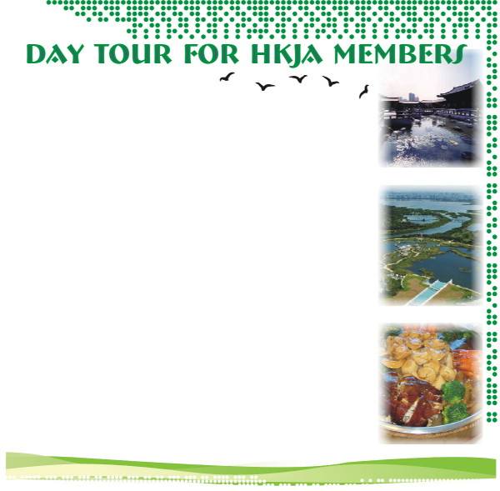



10 seats left for Day Tour! Hurry Up
There are only 10 seats left for the day tour to Wetland Park and Chi Lin Nunnery. All participants can enjoy “pun choy” and lucky drew, too. So grab the last chance to join us before January 1st, 2008.
Walk the Boardwalk! Be a Peeping Tom from the safety of the Riverside Hide. Dice with danger on the edge of Pui Pui’s “home”.
Yes, all these and more to excite you at the Wetland Park on the south-west edge of the Ramsar Site – specially organized by the Hong Kong Journalists Association (HKJA) for members, relatives and friends on 13th January 2008 – a day in the Spring when migratory birds flock here.
After that we’re off to Ping Shan for a traditional “pun choy” in a village house. The tour will be followed by a visit to Chi Lin Nunnery and Nan Lin Garden, an architectural feast of Tang Dynasty splendour with its garden of pines, ponds and graceful wooden structures built without the use of a single nail. There are many other wonderful plants in the garden for you to explore.
If you’ve never been to these places this is a must-see outing.
If you’ve not had “pun choy” for a while, this is the most delectable feasts available in Hong Kong.
And a lucky draw will start you off in the lunar New Year to come.
Fraternize with Fellow Members.

Book your place early for the HKJA outing on
Date: January 13th 2008
Time: Starting off at 9:00am, finishing at 5:00pm.
Fees: HKD $100 for members
HKD $130 for non-members
(Covering: transportation, lunch, ticket and travel insurance as well)
Max number of participants: 50 (on a first-come-first-served basis)
Assembly Point: Outside Romantic Hotel, True Light Lane, Kowloon Tong
(Turn left at exit F of Kowloon Tong MTR station)

You can pay directly to our HSBC account (No. 002-4-228298), please write you name on the transfer slip and fax it to 2572-7329 or e-mail them to hkja@hkja.org.hk together with the reply slip for confirmation. If you choose to pay by cheque, please make it payable to “HONG KONG JOURNALISTS ASSOCIATION” and mail to the JA office with the reply slip.

---------- Reply Slip ---------

Name:__________________________ Contact No.:__________________ Number of participants:___________

Organisation:________________________________ Email:__________________________________________

Are you HKJA member? : Yes ( ) No ( ) Membership No. (If yes): _______________

HKJA Address: Flat 15A, Henfa Commercial Building, 348-350 Lockhart Road, Wanchai, Hong Kong

